# **Name: Abdur R. Qureshi**

# **Roll No: 242466**

Assignment No: 1

Date Of Performance: 10/10/2025

Q: Implementation of React MCQ Applications

CODE (questions.tsx):

export type ChoiceId = "A" | "B" | "C" | "D"

export type Question = {

  id: string

  text: string

  choices: Array<{ id: ChoiceId; label: string }>

  correct: ChoiceId

}

export const QUESTIONS: Question[] = [

  {

    id: "q1",

    text: "Which map is themed around an abandoned Soviet cosmodrome?",

    choices: [

      { id: "A", label: "Ascension" },

      { id: "B", label: "Five" },

      { id: "C", label: "Der Riese" },

      { id: "D", label: "Classified" },

    ],

    correct: "A",

  },

  {

    id: "q2",

    text: "Which map is themed around a tropical temple lost in the mountains?",

    choices: [

      { id: "A", label: "Shangri-La" },

      { id: "B", label: "Shi No Numa" },

      { id: "C", label: "Buried" },

      { id: "D", label: "Zetsubou No Shima" },

    ],

    correct: "A",

  },

  {

    id: "q3",

    text: "Which map is themed around a destroyed city overrun by the undead in Paris?",

    choices: [

      { id: "A", label: "Der Eisendrache" },

      { id: "B", label: "Mauer der Toten" },

      { id: "C", label: "Outbreak" },

      { id: "D", label: "Tranzit" },

    ],

    correct: "B",

  },

  {

    id: "q4",

    text: "Which map takes place in a German castle used for secret experiments?",

    choices: [

      { id: "A", label: "Der Eisendrache" },

      { id: "B", label: "Moon" },

      { id: "C", label: "Origins" },

      { id: "D", label: "Classified" },

    ],

    correct: "A",

  },

  {

    id: "q5",

    text: "Which map has a Cold War theme set inside the Pentagon?",

    choices: [

      { id: "A", label: "Five" },

      { id: "B", label: "Die Maschine" },

      { id: "C", label: "Classified" },

      { id: "D", label: "Firebase Z" },

    ],

    correct: "A",

  },

  {

    id: "q6",

    text: "Which boss is an electrified being that floats and uses energy attacks?",

    choices: [

      { id: "A", label: "Avogadro" },

      { id: "B", label: "Panzer Soldat" },

      { id: "C", label: "Brutus" },

      { id: "D", label: "Margwa" },

    ],

    correct: "A",

  },

  {

    id: "q7",

    text: "Which boss appears in Shadows of Evil and has multiple heads?",

    choices: [

      { id: "A", label: "Margwa" },

      { id: "B", label: "Blightfather" },

      { id: "C", label: "Keeper" },

      { id: "D", label: "Warden" },

    ],

    correct: "A",

  },

  {

    id: "q8",

    text: "Which boss is known for locking perk machines and chasing players on Alcatraz?",

    choices: [

      { id: "A", label: "Brutus" },

      { id: "B", label: "Avogadro" },

      { id: "C", label: "Panzer Soldat" },

      { id: "D", label: "Thrasher" },

    ],

    correct: "A",

  },

  {

    id: "q9",

    text: "Which boss appears as a mutated plant creature in Zetsubou No Shima?",

    choices: [

      { id: "A", label: "Thrasher" },

      { id: "B", label: "Panzer Soldat" },

      { id: "C", label: "Warden" },

      { id: "D", label: "Avogadro" },

    ],

    correct: "A",

  },

  {

    id: "q10",

    text: "Which boss is a massive mechanical drone that attacks in Origins?",

    choices: [

      { id: "A", label: "Giant Robot" },

      { id: "B", label: "Thrasher" },

      { id: "C", label: "Margwa" },

      { id: "D", label: "Brutus" },

    ],

    correct: "A",

  },

  {

    id: "q11",

    text: "Which Wonder Weapon combines two guns into one on the Moon map?",

    choices: [

      { id: "A", label: "Wave Gun" },

      { id: "B", label: "Scavenger" },

      { id: "C", label: "Thundergun" },

      { id: "D", label: "Ray Gun Mark II" },

    ],

    correct: "A",

  },

  {

    id: "q12",

    text: "Which Wonder Weapon uses black holes to suck in zombies?",

    choices: [

      { id: "A", label: "Gersch Device" },

      { id: "B", label: "QED" },

      { id: "C", label: "Thundergun" },

      { id: "D", label: "Sliquifier" },

    ],

    correct: "A",

  },

  {

    id: "q13",

    text: "Which Wonder Weapon fires purple energy that creates mini black holes?",

    choices: [

      { id: "A", label: "Apothicon Servant" },

      { id: "B", label: "Thundergun" },

      { id: "C", label: "Ray Gun" },

      { id: "D", label: "Winter’s Howl" },

    ],

    correct: "A",

  },

  {

    id: "q14",

    text: "Which Wonder Weapon was introduced in Call of the Dead and acts like a sniper?",

    choices: [

      { id: "A", label: "Scavenger" },

      { id: "B", label: "Thundergun" },

      { id: "C", label: "Wunderwaffe DG-3" },

      { id: "D", label: "Ray Gun" },

    ],

    correct: "A",

  },

  {

    id: "q15",

    text: "Which Wonder Weapon transforms zombies into harmless crawlers on impact?",

    choices: [

      { id: "A", label: "Shrink Ray (31-79 JGb215)" },

      { id: "B", label: "Apothicon Servant" },

      { id: "C", label: "Thundergun" },

      { id: "D", label: "Wave Gun" },

    ],

    correct: "A",

  },

  {

    id: "q16",

    text: "Which perk increases reload speed?",

    choices: [

      { id: "A", label: "Speed Cola" },

      { id: "B", label: "Stamin-Up" },

      { id: "C", label: "Juggernog" },

      { id: "D", label: "Quick Revive" },

    ],

    correct: "A",

  },

  {

    id: "q17",

    text: "Which perk increases health, allowing more hits before going down?",

    choices: [

      { id: "A", label: "Juggernog" },

      { id: "B", label: "Deadshot Daiquiri" },

      { id: "C", label: "PhD Flopper" },

      { id: "D", label: "Double Tap" },

    ],

    correct: "A",

  },

  {

    id: "q18",

    text: "Which perk allows you to carry three weapons?",

    choices: [

      { id: "A", label: "Mule Kick" },

      { id: "B", label: "Stamin-Up" },

      { id: "C", label: "Double Tap" },

      { id: "D", label: "Electric Cherry" },

    ],

    correct: "A",

  },

  {

    id: "q19",

    text: "Which perk creates an electric shock when reloading?",

    choices: [

      { id: "A", label: "Electric Cherry" },

      { id: "B", label: "Speed Cola" },

      { id: "C", label: "Deadshot Daiquiri" },

      { id: "D", label: "Quick Revive" },

    ],

    correct: "A",

  },

  {

    id: "q20",

    text: "Which perk negates explosive damage when diving to prone?",

    choices: [

      { id: "A", label: "PhD Flopper" },

      { id: "B", label: "Juggernog" },

      { id: "C", label: "Double Tap" },

      { id: "D", label: "Quick Revive" },

    ],

    correct: "A",

  },

]

OUTPUT:

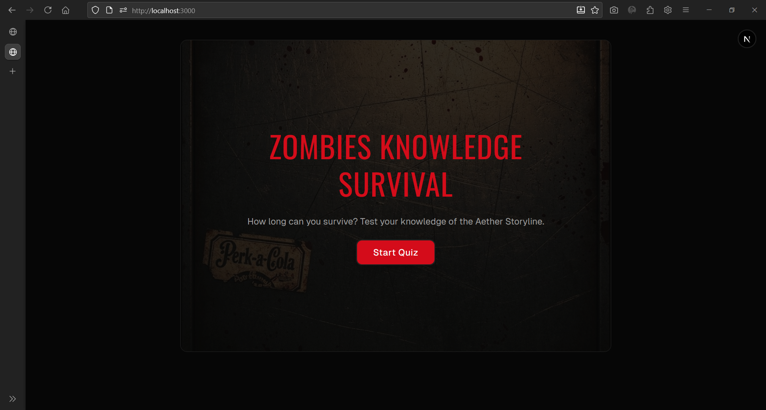

Start Page of quiz (MCQ)

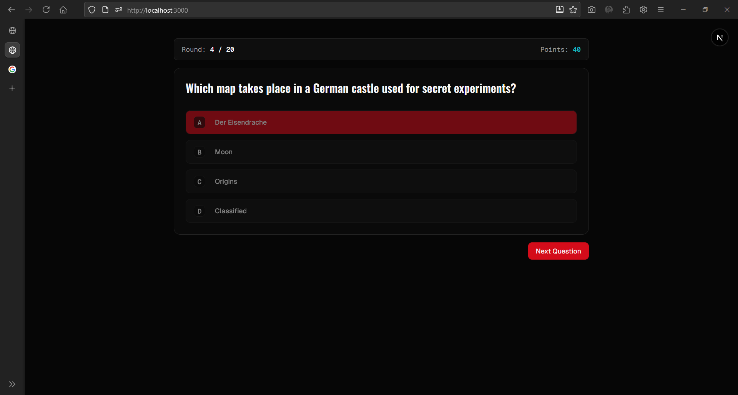

Question 4:

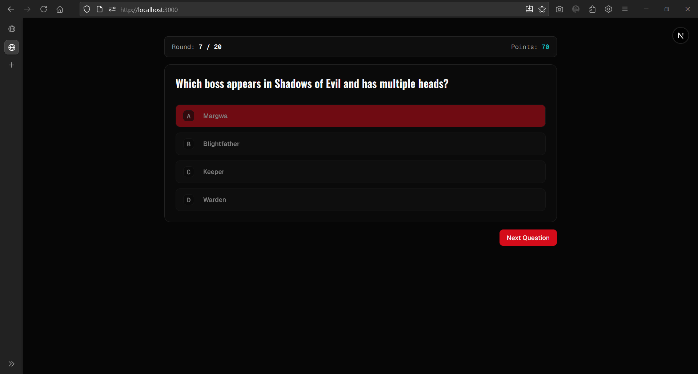

Question 7:

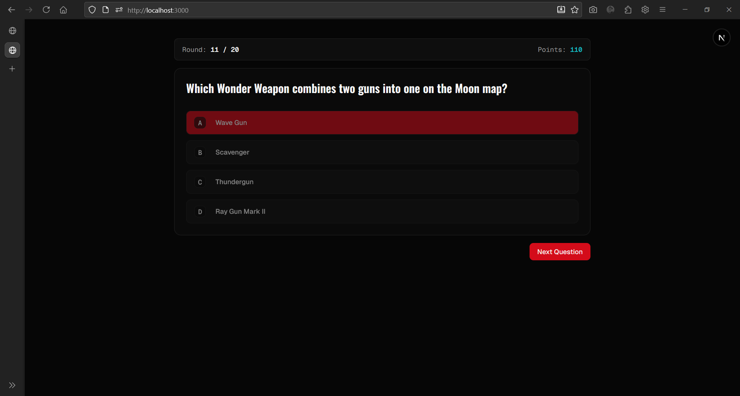

Question 11:

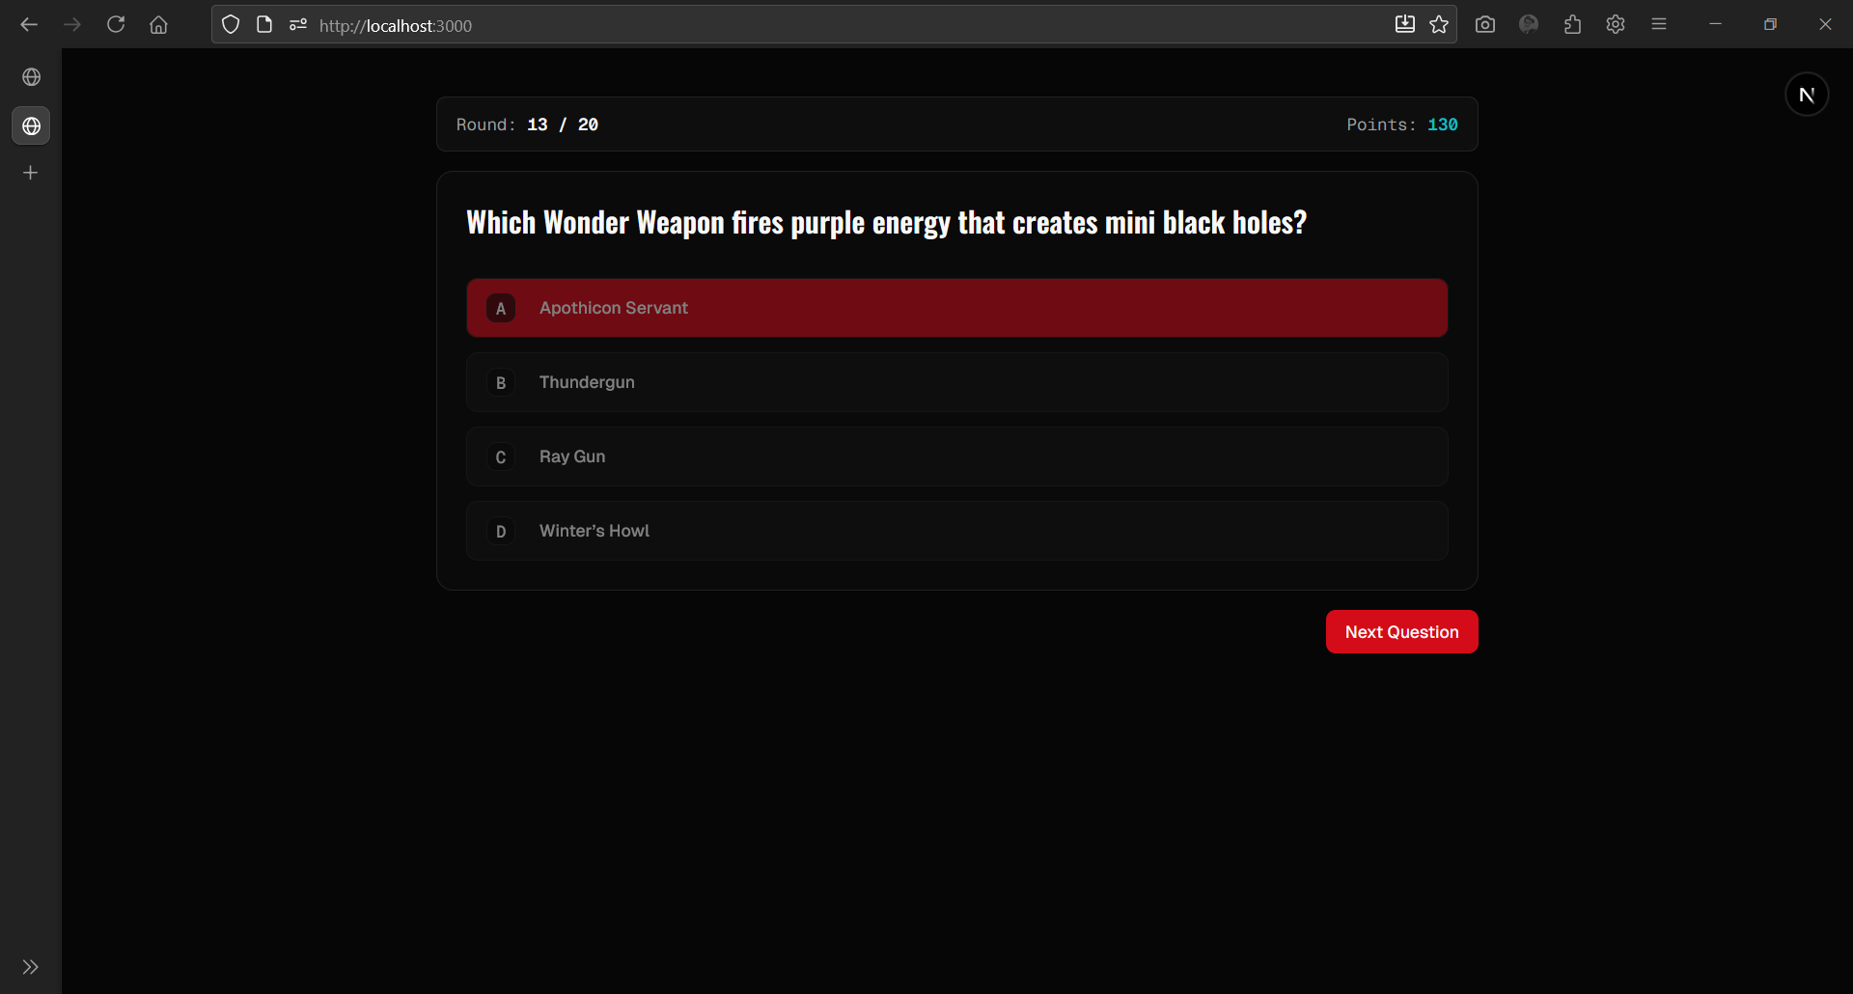

Question 13:

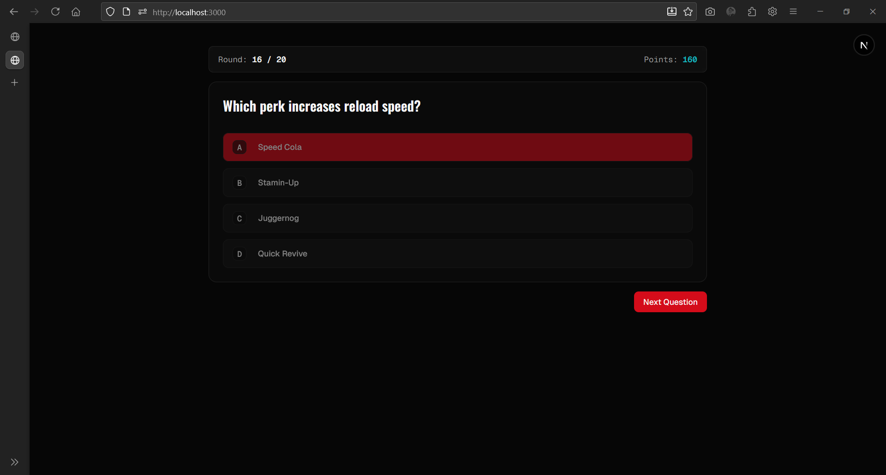

Question 16:



Final Result